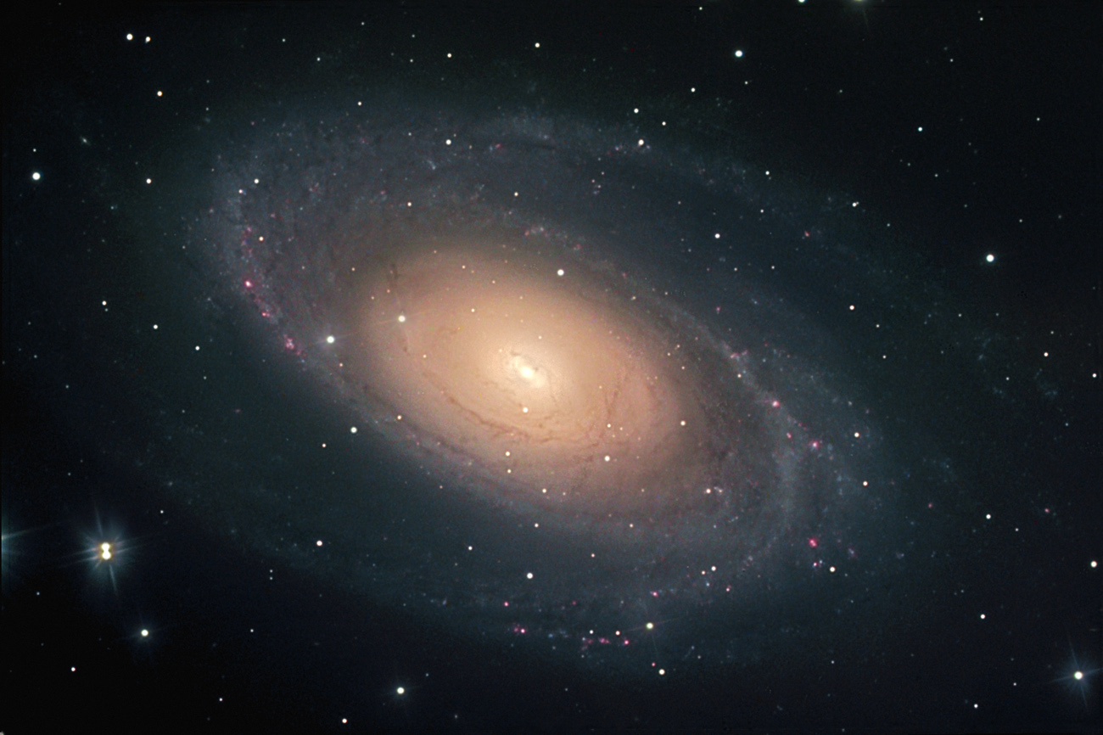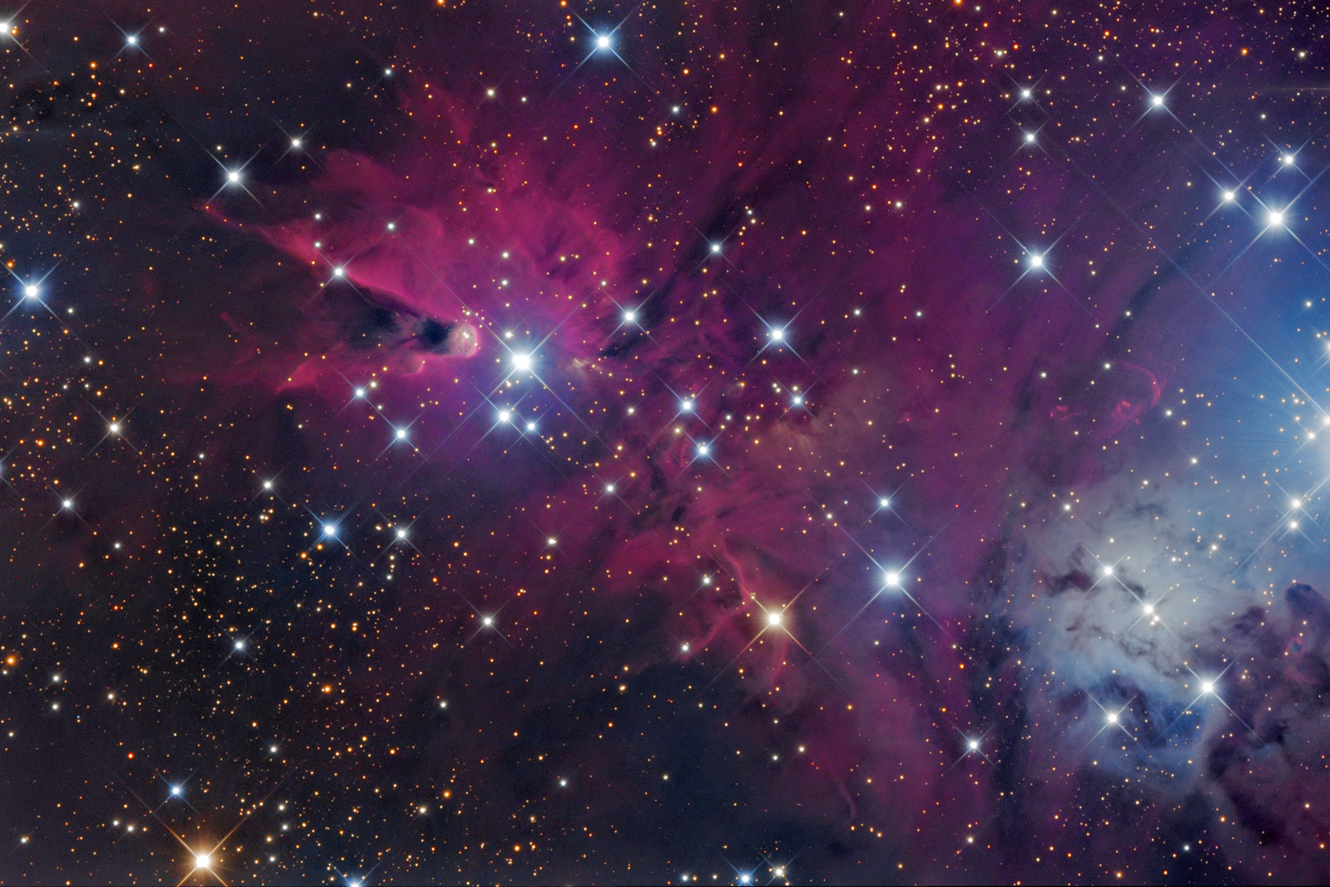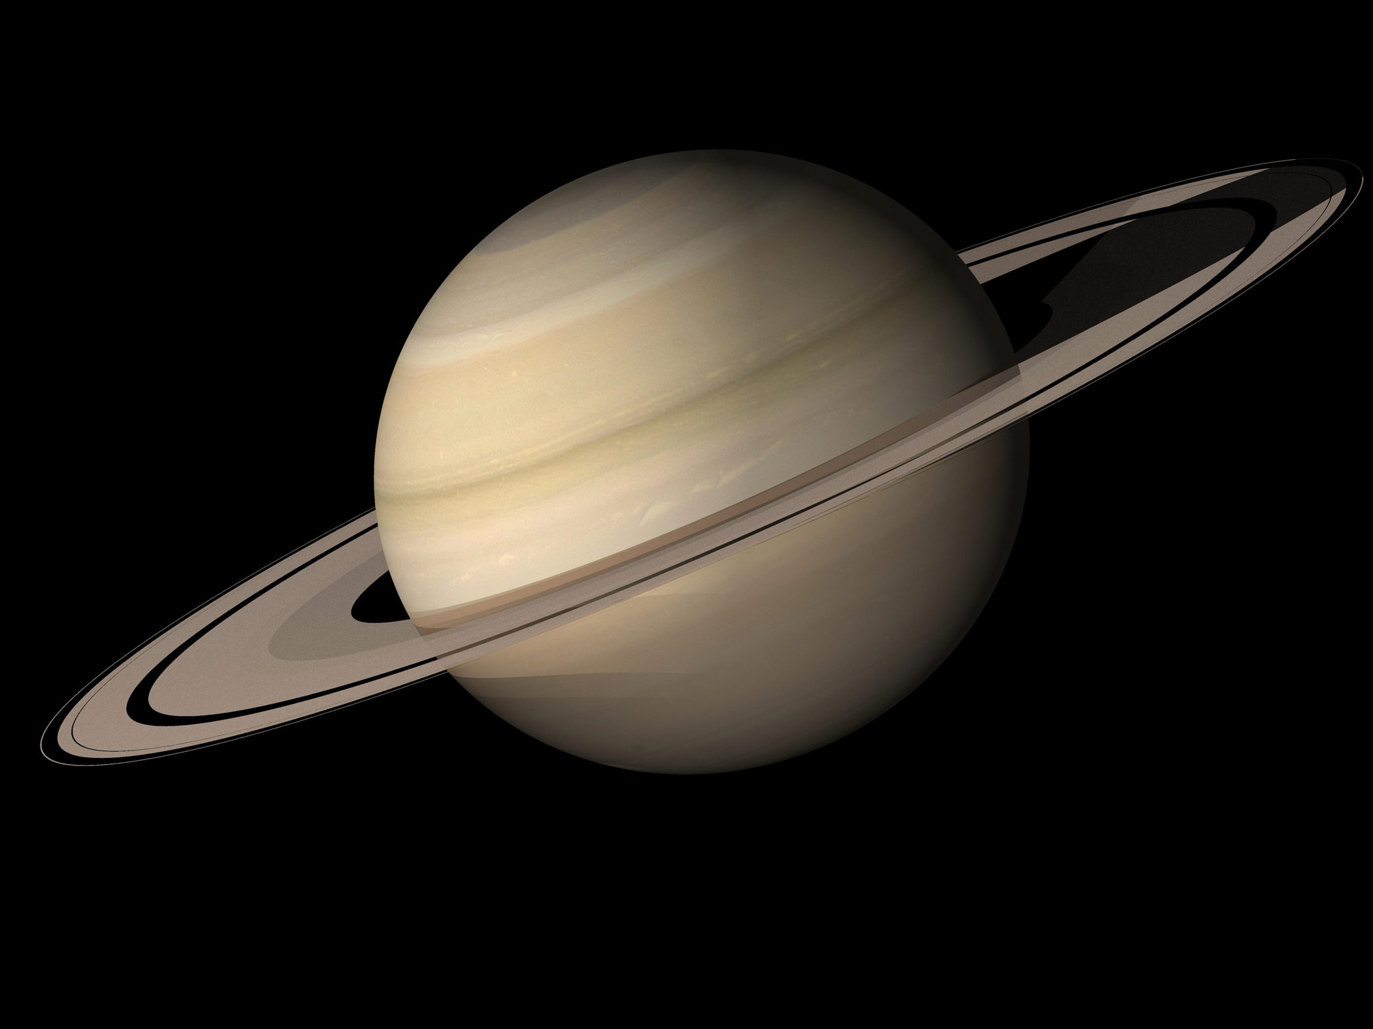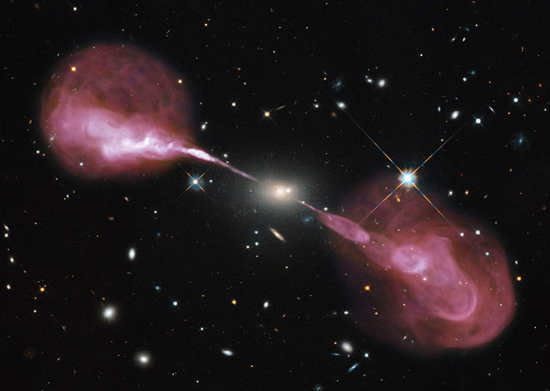

The Astronomy Major at Wesleyan
The Wesleyan Astronomy Department provides outstanding opportunities for undergraduates interested in this fascinating subject. Our unique program blends course work with research experiences and provides students with access to professional-level telescopes. Faculty work one-on-one with undergraduates as they investigate current research topics. Students who major in Astronomy often go on to PhD programs, including some of the best in the country, as well as a range of careers in data science, education and public outreach, systems engineering, and more. The major itself consists of six Astronomy courses – two gateway courses, ASTR 155 and 211, and four advanced 200-level courses – as well as several supporting Math and Physics courses. Below is an example eight-semester plan for the Astronomy major.
Semester 1  ASTR 155ª/elective  PHYS 113  MATH 121  GenEd^{b} | Semester 2  PHYS 116  MATH 122  GenEd^{b}  elective | Semester 3  ASTR 155ª/elective  ASTR 210^{c}  PHYS 213  MATH 221  GenEd^{b} | Semester 4  ASTR 211  PHYS 214  MATH 222^{d}  GenEd^{b}
Semester 5  ASTR 2XX  PHYS 324^{d}  PHYS 215  GenEd^{b} | Semester 6  ASTR 2XX  PHYS 313^{d}  MATH 229^{d}/elective  GenEd^{b} | Semester 7  ASTR 2XX  ASTR 409e  ASTR 430^{f}  PHYS 315^{d}  elective | Semester 8  ASTR 2XX  ASTR 410e  ASTR 431^{f}  PHYS 316^{d}  elective

ª ASTR 155 can be taken in the first or third semester. The major can be completed either way, provided
that PHYS 113/116 and MATH 121/122 have been taken (or placed out of) prior to Semester 3.

^{b} “GenEd” refers to HA or SBS general education courses. The NSM component of the general education
expectation is automatically fulfilled by the ASTR, PHYS, and MATH courses listed here.

^{c} A 0.5-credit computing course that must be completed prior to taking ASTR 211.

^{d} Not required, but highly recommended for those considering graduate study in astronomy or astrophysics.
Check WesMaps to confirm these courses are offered in the semesters listed here.

^{e} Optional senior honors thesis credit.

^{f} 0.25-credit seminars; highly recommended for all majors, and required in the senior year as part of the
senior capstone if no other experience qualifies.
Additional Information…
Which introductory astronomy course is right?
The Department offers two types of introductory courses: an array of fascinating general education courses (ASTR 102, 105, 106, 108, 111) designed for non-science majors, and the more technical Introduction to Astrophysics (ASTR 155), for which familiarity with calculus and high school-level physics is expected. Regardless of your future major, if you have good math and physics skills and enjoy solving quantitative problems, you should consider ASTR 155. Both types of courses offer opportunities to view the night sky with the Department’s telescopes.
Double majors with Astronomy:
Double majors with Astronomy are common. Many students (particularly those planning to pursue graduate study) choose to double in Physics, as many of the requirements for that major are fulfilled when the upper-level PHYS and MATH courses listed in the 8-semester plan are taken. Computer science is also a popular major to pair with Astronomy.
The number of electives, HA/SBS GenEd courses, and optional upper-level PHYS and MATH courses listed in the 8-semester plan leave open the possibility of double majors in non-science subjects. Some recent examples include History, Religion, Dance, Music, Philosophy, English, Film, Anthropology, and Studio Art.
Planetary Science minor:
Planetary Science is an interdisciplinary field that explores the origin and evolution the solar system in which we live and planetary systems that have been identified elsewhere in our Galaxy. Students can earn a minor in Planetary Science by taking a set of 5 courses in ASTR and E&ES along with several offerings of ASTR/E&ES 555, the 0.25-credit Planetary Science Seminar. See the on-line program description for more information.
Study abroad:
Majors take an upper-level astronomy course each semester of their junior and senior years. Coupled with the fact that only a fraction of Wesleyan-approved study abroad programs offer astronomy courses, this makes study abroad difficult, but not impossible. See the Chair of the Astronomy Department to discuss study abroad options.
Research opportunities:
Research is an integral part of an Astronomy education, and members of the faculty provide one-on-one research opportunities for students during the academic year or the summer months. This work sometimes involves observing on the Department’s 0.6-m telescope. Alternatively, students often obtain summer research positions off-campus as part of a national REU program such as the Keck Northeast Astronomy Consortium program, in which Wesleyan participates. Many Astronomy majors also complete a senior honors thesis under the supervision of one of the faculty.
Public Outreach:
The Department hosts numerous public science events throughout the academic year, which include observing with our 20- and 24-inch telescopes as well as classroom activities and presentations. These events, which are often led by our majors and graduate students as paid positions, provide excellent opportunities to share the wonders of the night sky with members of the public of all ages.

